St Ivo Racquets Club
ST. IVO RACQUETS CLUB
Racquetball Club Championships 2015
As a long time squash player, I admit to being slightly sniffy about Racquetball in the past, but after relentless nagging by those who are keen, I did have a go and quite enjoyed it! Yes the bigger ball bounces more, the racket shorter, but the principle is the same, you work your opponent until he can’t play the next shot, or you can play the winner.
And so to the Racquetball Club Champs that were held on Thursday 16th April 2015, 8 players turned up for an evening of friendly competition. The format was a knockout tournament with the first round losers entered into the plate, organised as always by our effervescent reggae man! It was best of 3 games PAR 15, but a lot of matches to get through, some going to 3 games with tiebreaker scores in the third. And embarrassingly I found myself seeded!! The plate final was contested by Derek and Adam, Derek proving too strong for Adam who has just come back from a long layoff, next year he will be stronger! The main final saw Langton(3) take on James(1), they were closely matched, this will be good. The first two games were keenly fought, both players gaining one apiece 11-9, so all to play for in the decider. It was reminiscent of the ‘Rumble in the Jungle’ both players trading body blows and the scoring evenly matched until Langton had match point at 10-9, but James pulled back to 10 all, then Langton’s match point again! But two more to James saw his match point at 12-11, only to lose the next rally and evens again!! And that’s how it continued, with no breakthrough, nerves were jangling like tubular bells and the marker was on his knees - ‘Please someone win!!’ At 19-18 Langton dealt the knockout punch, and the champion was decided – good gawd its quarter to eleven!!
So now to the thanks; firstly to England Squash and One Leisure who provided all the prizes, and secondly to all those who attended to make the competition worthwhile, and of course it wouldn’t happen if it wasn’t for Byron, so 3 cheers to him. Roll on next year!
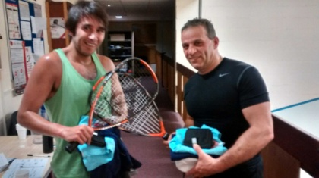
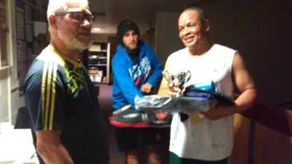

Plate winner and runner up
Derek and Adam
St Ivo Racquet Ball Champion 2015 Langton Takanira

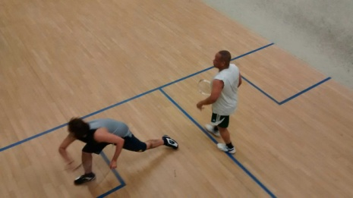

Langton and James in action
Players competing:
Derek Darnell, James Weir, Gary Mason, Steve Wilson, Kevin Doyle, Langton Takanira, Adam Weir and yours truly.
Report by Alistair Paul

